HW1: Mid-term assignment report

*Gabriel Hall Abreu [102851]*, 2023-04-10

1.1 Overview of the work 1

1.2 Current limitations 1

2.1 Functional scope and supported interactions 1

2.2 System architecture 2

2.3 API for developers 2

3.1 Testing 2

3.2 Code quality analysis 3

3.3 Continuous integration pipeline [optional] 3

# Introduction

## Overview of the work

This report presents the midterm individual project required for TQS, covering both the software product features and the adopted quality assurance strategy.

AirQuality web app aims to present to the user the current air pollution for a given city of a given country.

## Current limitations

Cache system not implemented.

No error messages are being displayed if the api doesn’t find any information for the given inputs.

# Product specification

## Functional scope and supported interactions

The only scenario for my web app is when a user wants to get the current air pollution of a certain city.

## System architecture

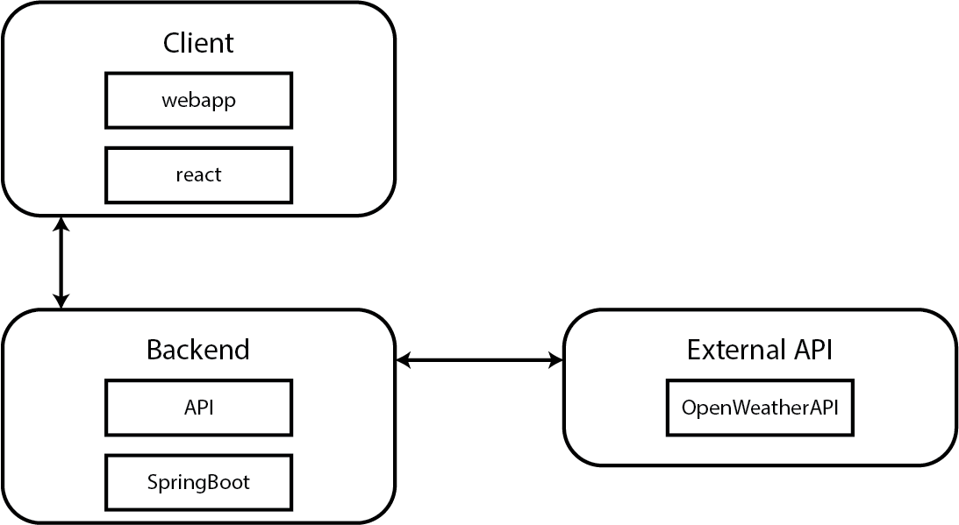

## API for developers

My API has 2 endpoints:

GET /air-pollution?lat={latitude}&lon={longitude}

Get current air pollution for a given latitude and longitude

GET /geolocation?city={city}&countryCode={code}

Get coordinates for a given city and country code

# Quality assurance

## Testing

1. Unit tests to test my models (CurrentAirPollution and Geocoding)
2. Service level tests, with dependency isolation using mocks to test my controllers (AirPollutionControllerTest & GeocodingControlerTest)
3. Integration test on my own API using REST-Assured (AirPollutionControllerIT).
4. Functional testing (on the web interface using Selenium WebDriver and Cucumber (SearchForAveiroSteps & SearchForAveiroTest).

## Code quality analysis

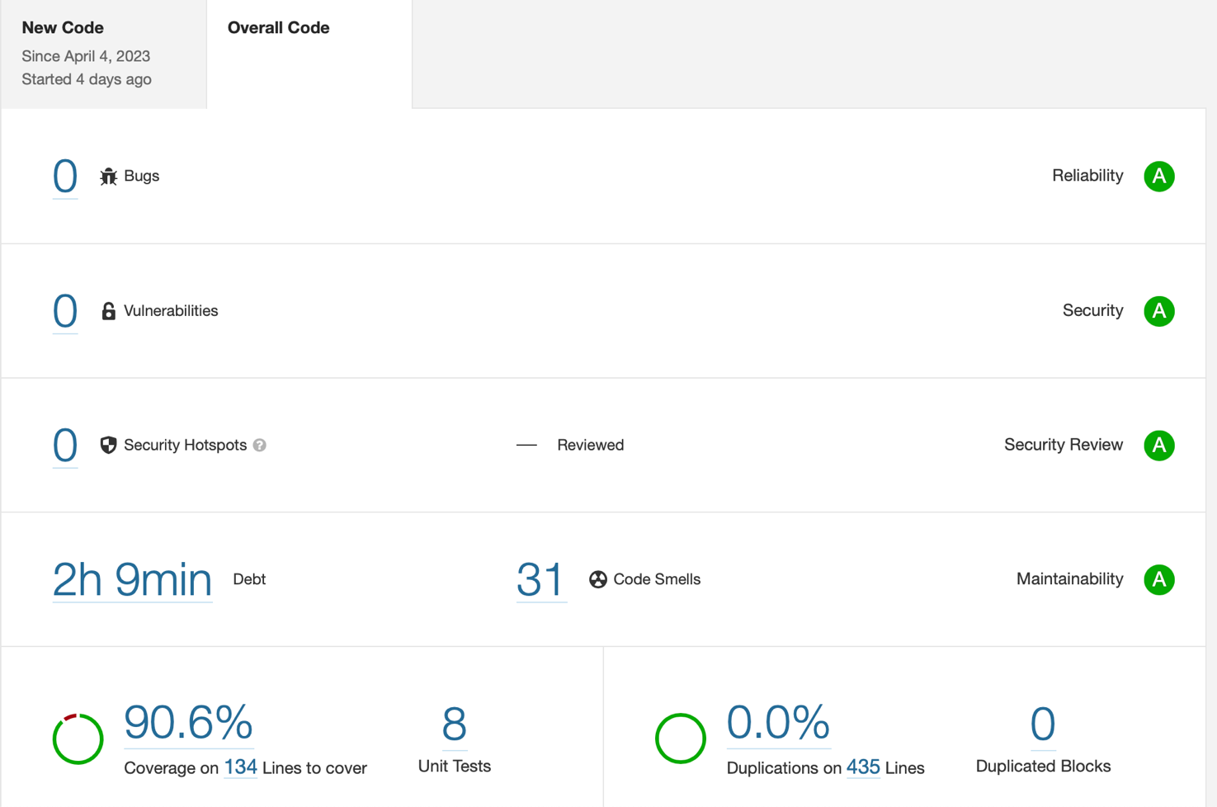

Sonarqube

## Continuous integration pipeline [optional]

-------

# References & resources

Project resources

|  |  |
| --- | --- |
| **Resource:** | **URL/location:** |
| Git repository | <https://github.com/GabrielHall02/TQS_102851/tree/main/HW1> |
| Video demo | <https://github.com/GabrielHall02/TQS_102851/blob/main/HW1/Screen%20Recording.mov> |

Reference materials

<https://openweathermap.org/api>